Q1. What is this button called? | 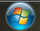
- Start

Q2. What is the difference between left-mouse-click and right-mouse-click?
- Left: Selects Right: Gives options

Q3. What happens when you press CTRL and ALT and DEL together at the same time?
- It gives you options about the computer

 | A B C D E
Q4. What do these cursors mean? | 
- Browse
- Select
- Type
- Loading
- Forbidden
Q5. Label the diagram given below:
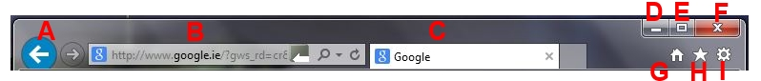
A - Back
B - Search/ URL bar
C – Tab
D - Minimise
E - Expand
F – Exit window
G - Home
H - Favourites
I - Browser Settings

